Year 9 Music
Part 1 | Instrumental Performance Exam | 70% | 1 minute (approx.)
Success Criteria | You have already completed this exam playing ‘Wait For It’ on your chosen musical instrument.

Part 2 | Music Listening & Theory Exam | 30% | 30 minutes
Success Criteria | You will take this exam on a computer. To answer the questions, you need to know the following key musical terms and features:
  Tempo | Structure | Dynamics | Instruments
  - Largo  - Adagio  - Andante  - Allegro  - Presto  - Ritardando  - Accelerando | - Repeat symbols  - Binary form (AB)  - Ternary form (ABA)  - Verse-chorus form  - Intro  - Verse  - Pre-chorus  - Chorus | - Pianissimo  - Piano  - Mezzo piano  - Mezzo forte  - Forte  - Fortissimo  - Crescendo  - Diminuendo | - Brass  - Woodwind  - Strings  - Percussion  - Keyboards  - Orchestra  - Choir  - Jazz Band  - Rock band
  Rhythm | Melody | Harmony
  - Durations  (note lengths)  - Tied notes  - Dotted notes  - Syncopation | - Pitch (high / low)  - Legato  - Staccato  - Anacrusis  - Ostinato | - Chord  - Major  - Minor  - Chord progression  - Broken chord
  Musical Symbols & Notation
  General | 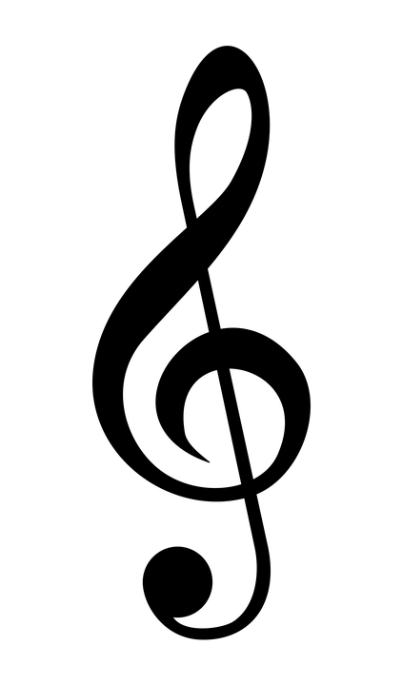 | 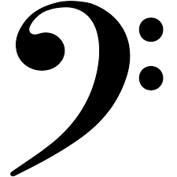 | 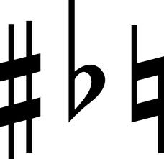 |  |  |  | 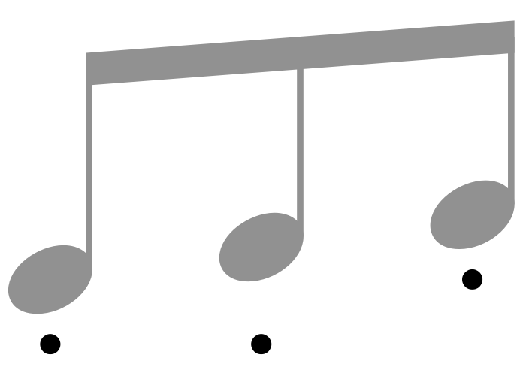
  Notes | 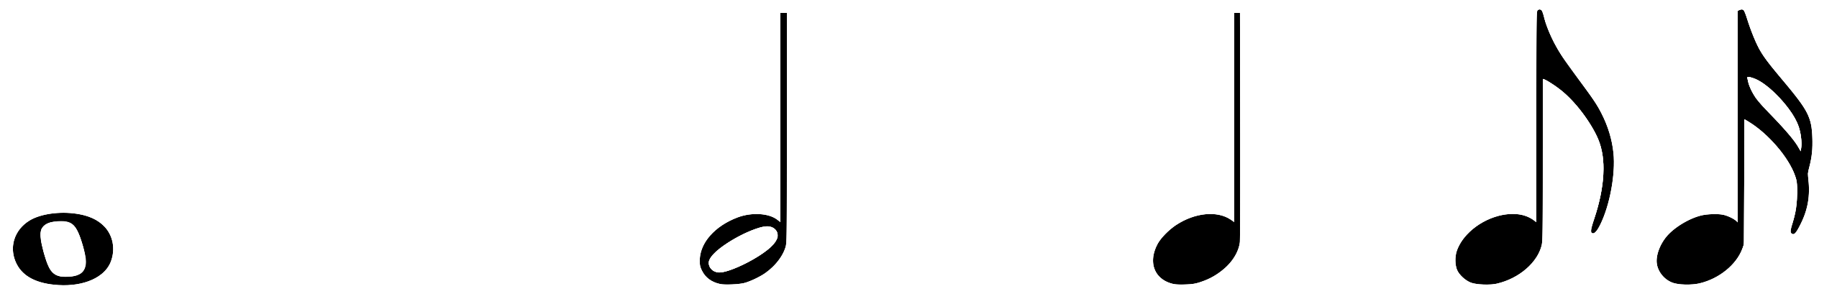 | 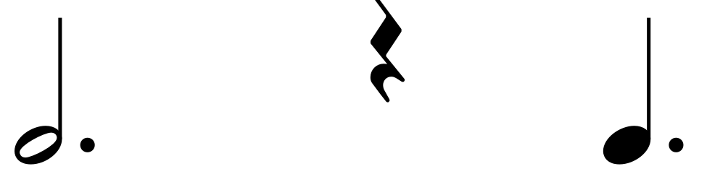
  Rests | 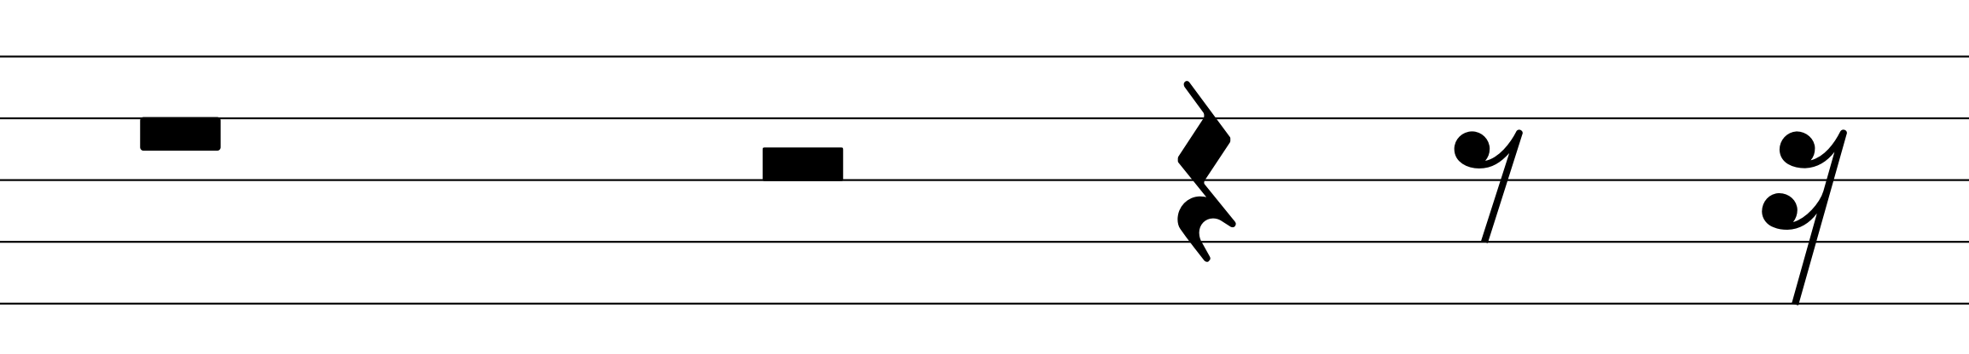
  Dynamics |  |  |  | 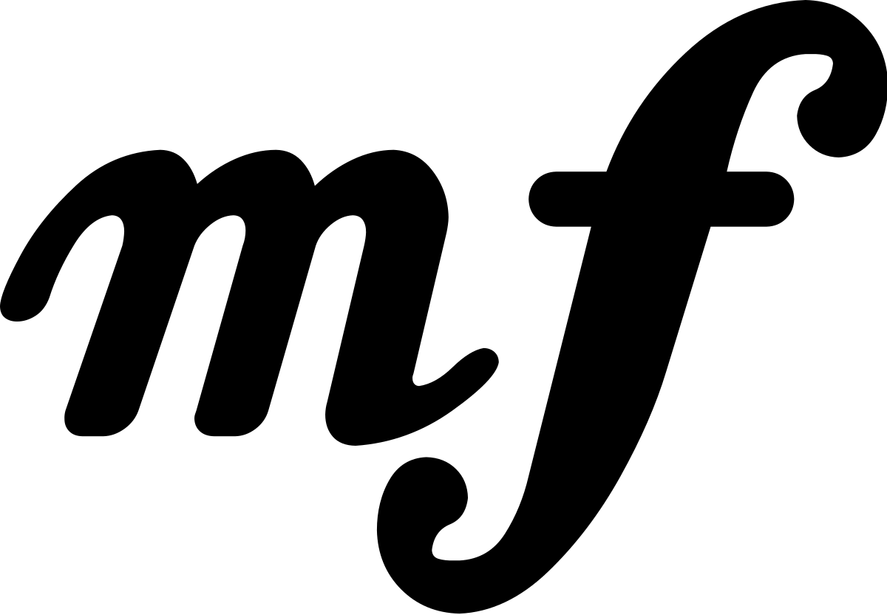 | 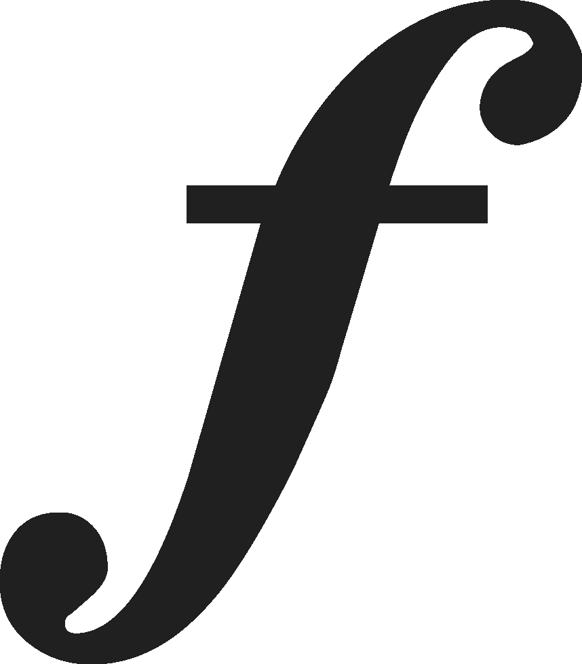 | 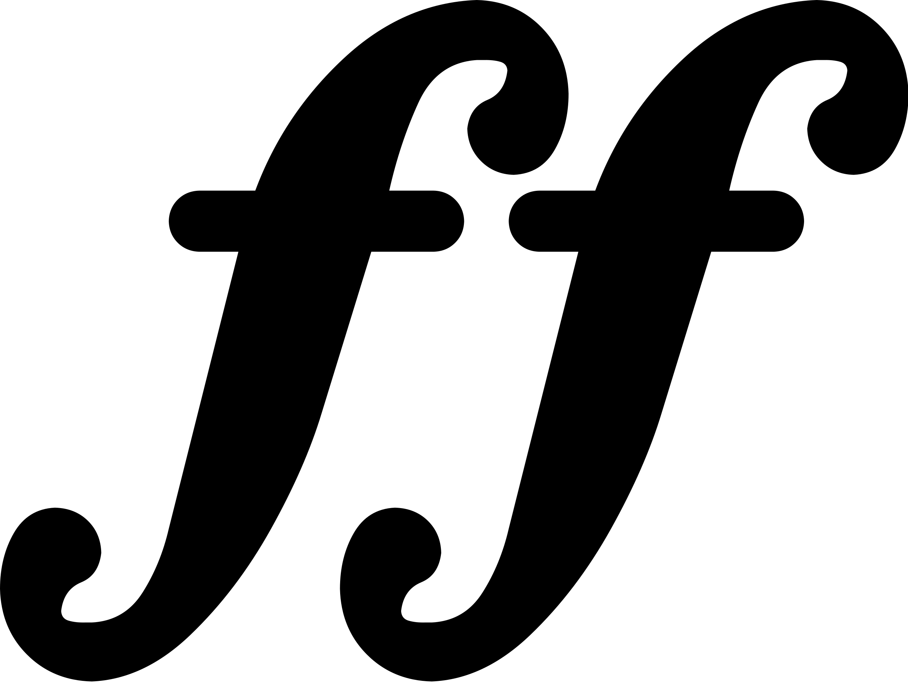
  Repeats |  |  | 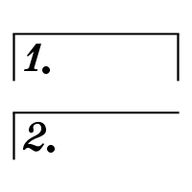
  Notes of the Treble Clef (Letter Names) | 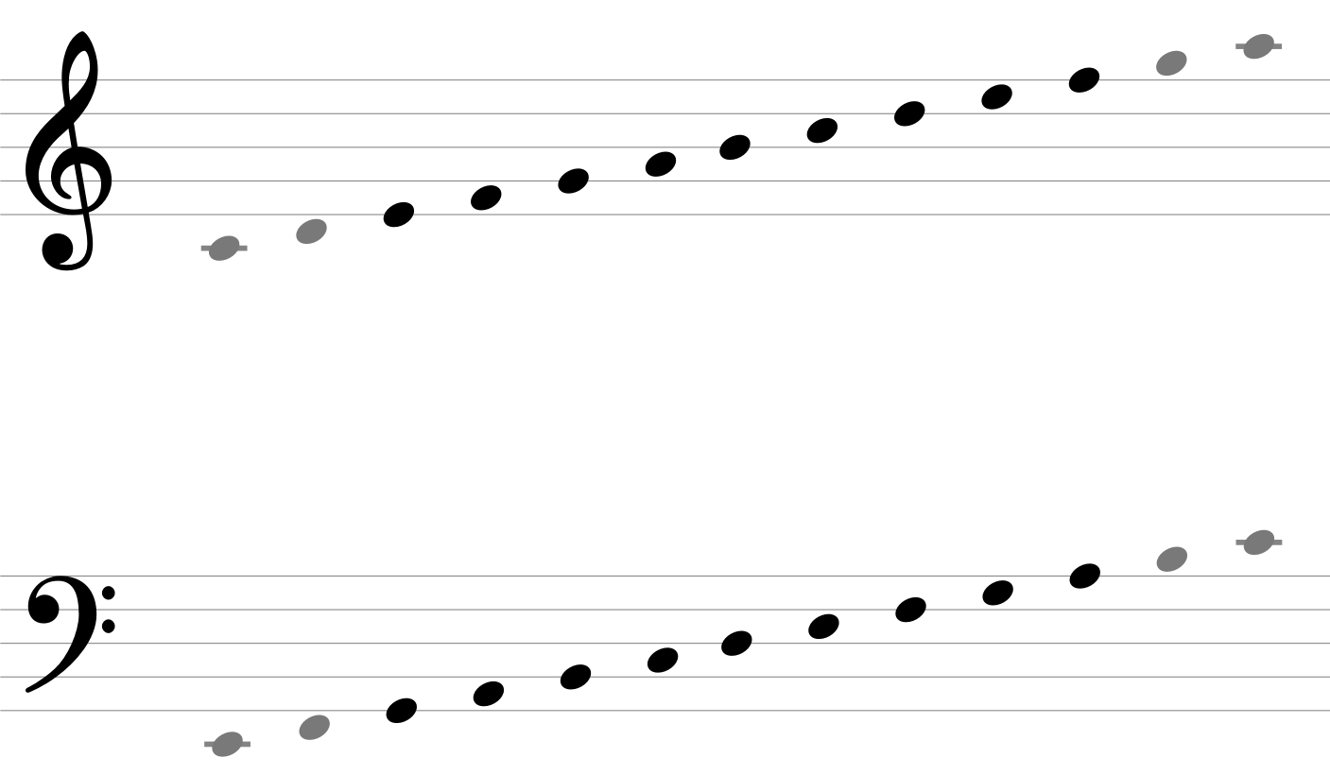
  Notes of the Bass Clef (Letter Names)

Revision Resources |  | Knowledge Organiser  Spring / Summer Term |  | MusicTheory.net    musictheory.net/lessons
Revision Resources |  | Focus on Sound  portal.focusonsound.com |  | Duolingo (Music)    duolingo.com (or App Store)

